**BUG REPORT FOR KUBER INDUSTRIES**

**Name – Ashwini Patil**

**Device – OPPO F1s**

**Android version – 5.1**

**APK Version – 1.2**

**Bug ID –** **1**

Module Name – Login Page

Bug description – Page is not fixed.

Expected result – Page should be fixed.

Bug Image–

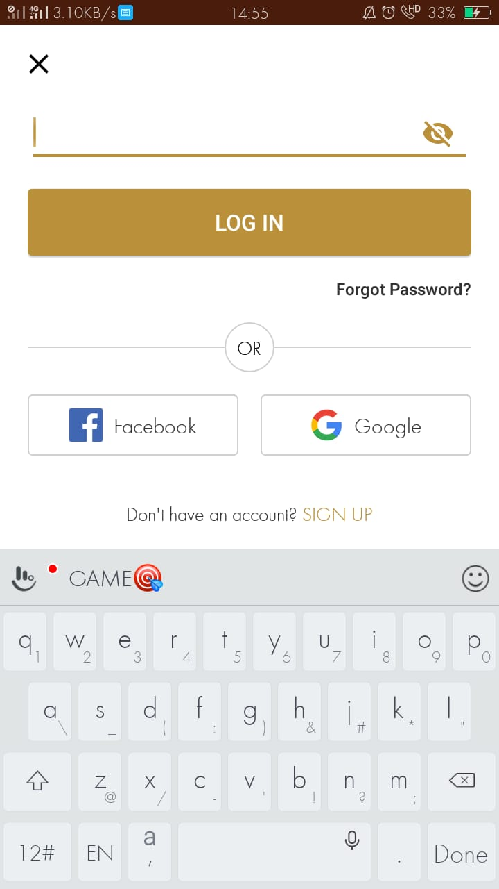

**Bug ID – 2**

Module Name – Login Page

Bug description – Validation messages for both Email and Password field is not proper.

Expected result – Validation messages for all the fields should be proper.

Bug Image –

**Bug ID – 3**

Module Name – Login Page

Bug description – Validation messages are not proper for Invalid details.

Expected result – Validation messages should be proper for Invalid details.

Bug Image –

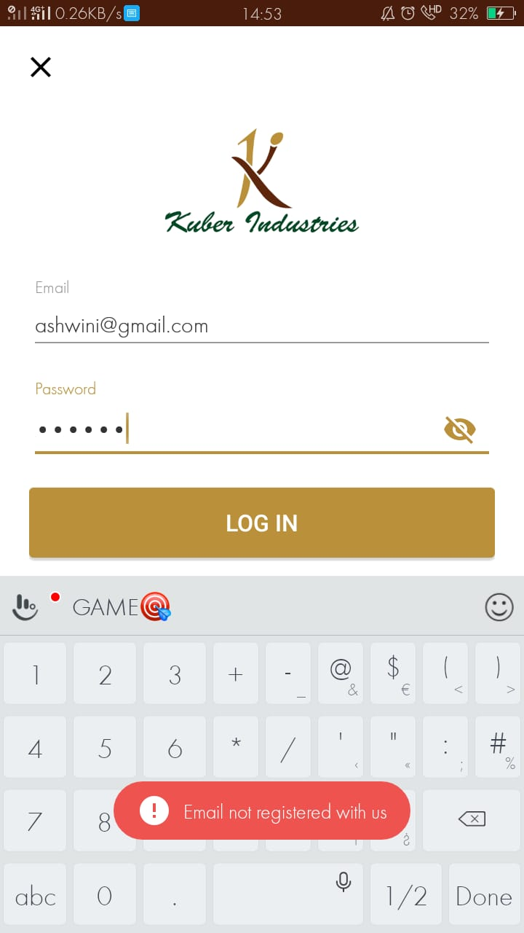

**Bug ID – 4**

Module Name – Login Page

Bug description – User redirect on Homepage when user is successfully Login.

Expected result – User should not redirect on Homepage when login is successful.

Bug Image –

**Bug ID – 5**

Module Name – Forgot Password

Bug description – When I click on back button after clicked on “SEND RESET LINK” it will redirect on homepage instead of Login page.

Expected result – The particular page should be redirect on Login page.

Bug Image –

**Bug ID – 6**

Module Name – Forgot Password

Bug description – Reset password link is sent to the Email-ID which is not registered.

Expected result – Reset password link should not sent to the Email which is not registered.

Bug Image –

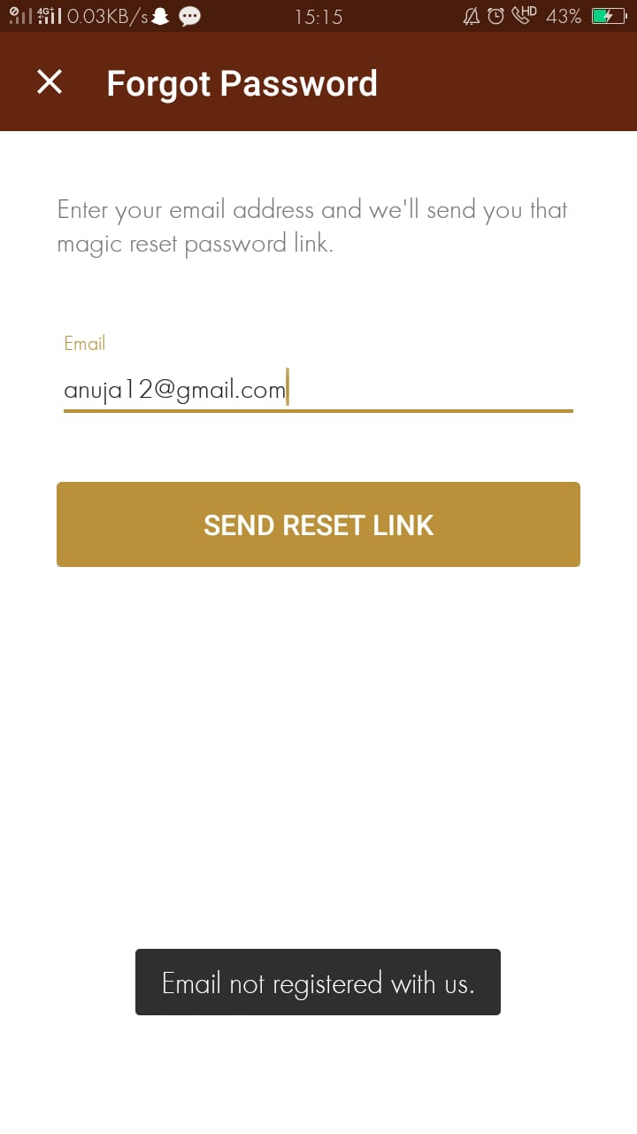

**Bug ID – 7**

Module Name – Forgot Password

Bug description – Password successfully changed with mismatch password.

Expected result – System should fire validation message for “Mismatch password”.

Bug Image -

**Bug ID – 8**

Module Name – Forgot Password

Bug description – Keypad is overlapped when enter New Password.

Expected result – Reset password link should not sent on the Email which is not registered.

Bug Image –

**Bug ID – 9**

Module Name – Forgot Password

Bug description – Validation message is not proper for both New Password and Confirm Password field.

Expected result – Validation messages should be proper for both the fields.

Bug Image –

**Bug ID – 10**

Module Name – Forgot Password

Bug description – Validation message and Confirm Password field is overlapped when New password field is blank.

Expected result – Validation message and Confirm Password field should not be overlapped.

Bug Image –

**Bug ID – 11**

Module Name – Search Bar

Bug description – Validation message is not proper when I search with Invalid product name.

Expected result – System should fire validation message for Invalid product name.

Bug Image –

**Bug ID – 12**

Module Name – Search Bar

Bug description – Validation message is not proper for available product.

Expected result – System should fire proper validation message for available product.

Bug Image –

**Bug ID – 13**

Module Name – Add to cart

Bug description – After adding three products it will show only two products are added.

Expected result – It will show the exact added product.

Bug Image –

**Bug ID – 14**

Module Name – Add to cart

Bug description – Product description is not visible.

Expected result – Product description should be visible to the customer.

Bug Image –

**Bug ID – 15**

Module Name – Add to cart

Bug description – Image does not open when I click on image.

Expected result – Image should be open for the customer.

Bug Image –

**Bug ID – 16**

Module Name – Add to cart

Bug description – Price option is not able open.

Expected result – Price option must be open.

Bug Image –

**Bug ID – 17**

Module Name – Add to cart

Bug description – Price option is not able open.

Expected result – Price option must be open.

Bug Image –

**Bug ID – 18**

Module Name – Filter

Bug description – Two options are there for selecting colors.

Expected result – Only one option must be there for selecting color.

Bug Image –

**Bug ID – 19**

Module Name – Filter

Bug description – No product is available when I select two different colors for the particular product.

Expected result – Product should be available when select two different colors.

Bug Image –

